**Got It!**

**1. Polar coordinates**

You've seen a lot of plot types so far, but one type has been conspicuously absent.

**2. Pie plots**

That's the pie plot. It's a wildly popular plot type, but we've been avoiding it for a good reason.

**3. ESPN famous athletes, by sport**

Here's the bar plot of famous athletes by sport.

**4. Bar plot + polar coords = pie plot**

If you convert the coordinate system for the plot from Cartesian coordinates, that is, standard x and y axes, to polar coordinates, you get a pie plot. A pie plot is just a bar plot where the bar lengths are converted to angles. Unfortunately, this plot is much harder to interpret than the bar plot. For example, it's really hard to answer questions that were easy with the bar plot, like "How many cricketers were on the list?". Data visualization research suggests that bar plots are almost always easier to interpret than pie plots.

**5. When should you use polar coordinates?**

So the answer to the question of when should you use polar coordinates is that they are almost never a good idea. There is one exception, though it is fairly niche. If you have data that has some natural circularity to it, like the time of day or a direction, then polar coordinates can be acceptable.

**6. Histogram of animal activity**

Here's a histogram of animal activity from the Panama camera trap dataset. You saw this as part of the pair plot in the previous chapter. It's a great plot with one problem: the activity from the nocturnal paca appears to be split in two, because the plot doesn't recognize that midnight on the left of the x-axis is the same as the midnight on the right of the x-axis.

**7. Histogram + polar coords = rose plot**

One possible fix is to convert the histograms to polar coordinates, forming a rose plot. This is slightly different to the pie plot because it's the x-axis that is converted to angles, and the bar heights still remain as lengths. Now if you look at the paca's activity distribution, it's clearer that it is one burst of activity lasting all night, rather than two separate bursts.

**8. Let's practice!**

Let's explore some circular plots!

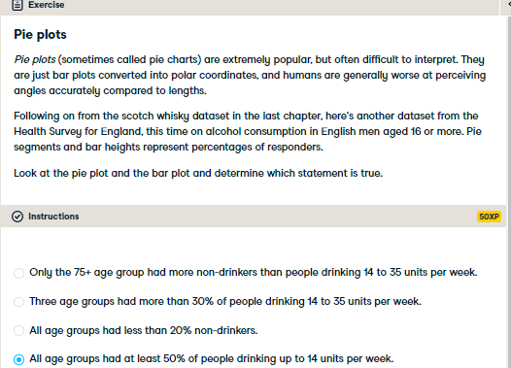

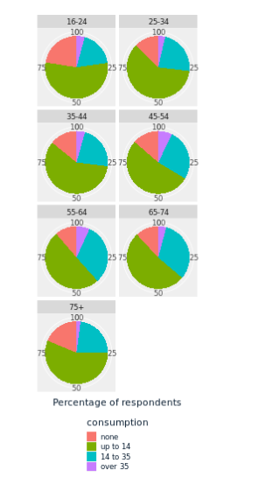

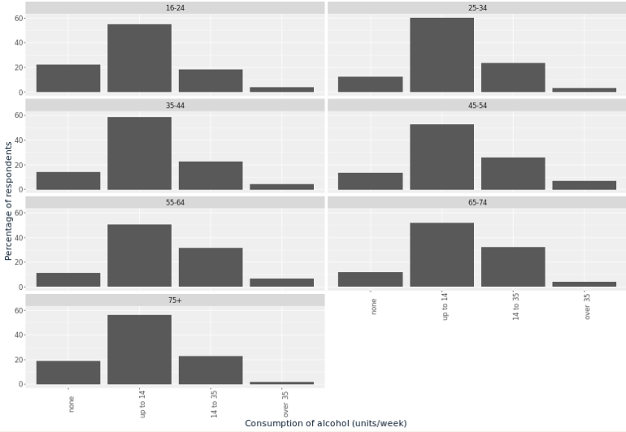

Delightful drinking plot interpretation! Polar coordinates are usually a bad idea. A bar plot is almost alway easier to interpret than a pie plot.

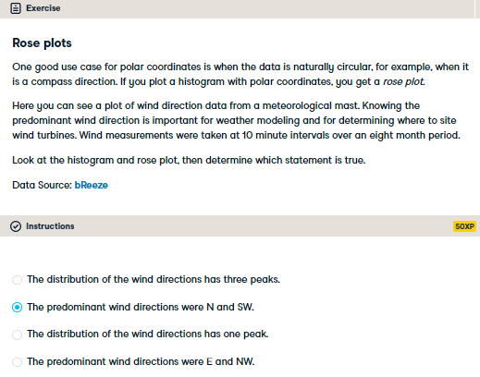

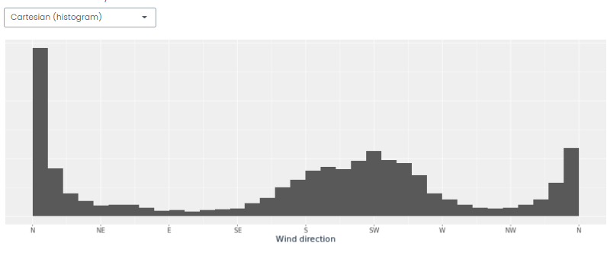

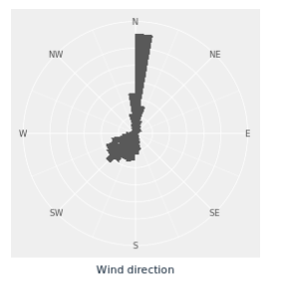

Wild wind interpreting! For cyclical data, polar coordinates can sometimes make a plot easier to interpret.